Project Design Phase-II
Technology Stack (Architecture & Stack)

Date | 03 August 2026
Team ID | N/A
Project Name | ShopEZ E-commerce Application
Maximum Marks | 4 Marks

Technical Architecture:
The Deliverable shall include the architectural diagram as below and the information as per the table1 & table 2
Example: Order processing during pandemics for offline mode

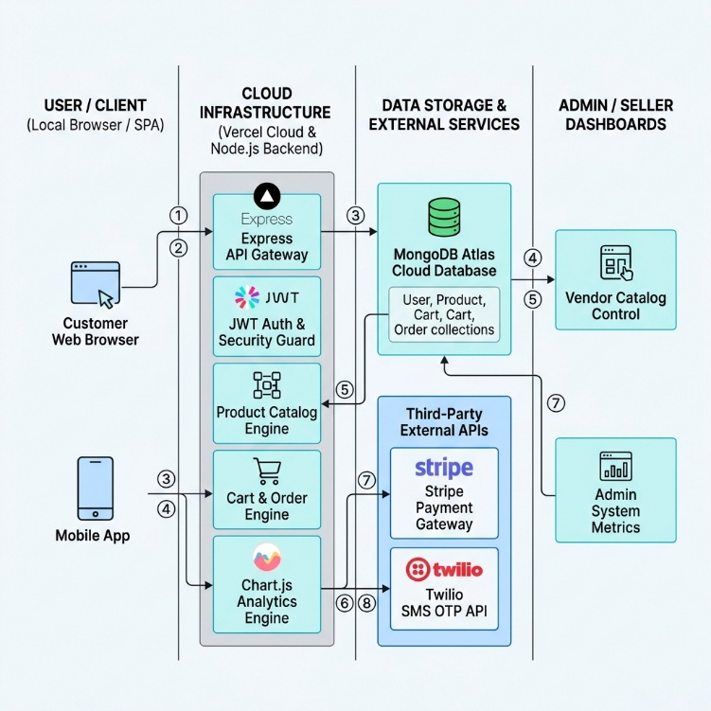
Guidelines:
he Shopez system architecture connects user devices to cloud-based e-commerce services through a streamlined, layered workflow. It begins at the local client layer where the mobile app or web browser captures photos, compresses them, and securely sends them through a cloud API gateway. This gateway routes requests to backend microservices that handle user authentication, cart operations, product catalogs, and order processing. For image searches, an integrated AI engine uses computer vision to extract visual features and run real-time vector database lookups to find matching items. Finally, persistent product and transaction data are saved in cloud databases, media assets are kept in cloud object storage, and external APIs seamlessly handle Stripe payments and Twilio notifications while admins manage everything via dedicated seller dashboards.

Table-1 : Components & Technologies:

S.No | Component | Description | Technology
 | User Interface | Visual e-commerce web platform and responsive cross-platform mobile application. | React.js, Tailwind CSS, React Native
 | Application Logic-1 | API Gateway, Routing, and User Authentication logic. | Node.js, Express.js, JWT
 | Application Logic-2 | E-commerce core engines (Cart, Order Processing, Catalog Management). | Python (FastAPI)
 | Application Logic-3 | Image preprocessing and feature extraction pipeline for visual search. | PyTorch, OpenCV
 | Database | Structured transaction, user account, and order history storage. | MongoDB / PostgreSQL
 | Cloud Database | Managed cloud database for vector embeddings and high-speed sim | Pinecone / MongoDB Atlas
 | File Storage | Cloud storage for high-resolution product photos, 360° views, and video reviews. | AWS S3 Bucket
 | External API-1 | Secure multi-currency payment processing gateway for checkout. | Stripe API
 | External API-2 | SMS notification service for account OTPs and real-time order status updates | Twilio API
 | Machine Learning Model | Computer vision AI model for multi-object detection and visual similarity matching. | YOLOv8 / CNN Feature Extractor
 | Infrastructure (Server / Cloud) | Cloud application hosting, containerization, and auto-scaling infrastructure. | AWS (EC2, ECS), Docker, Vercel

Table-2: Application Characteristics:

S.No | Characteristics | Description | Technology
 | Open-Source Frameworks | Core open-source libraries and frameworks used across frontend, backend, and machine learning modules. | React.js, React Native, Node.js, Express.js, PyTorch, OpenCV, Tailwind CSS
 | Security Implementations | Access controls, data protection, secure authentication, and web security standards for e-commerce transactions. | JWT, OAuth 2.0, AES-256 (Data Encryption at Rest), TLS 1.3 (Encryption in Transit), AWS IAM, AWS WAF, OWASP guidelines
 | Scalable Architecture | Modular microservices architecture enabling independent scaling of visual AI processing, product search, and cart operations. | Microservices Architecture, Docker Containerization, Kubernetes (AWS EKS), Node.js, FastAPI
 | Availability | High-availability setup using load balancing and multi-region cloud deployment to prevent downtime. | AWS Application Load Balancer (ALB), AWS Multi-AZ Deployment, Auto-Scaling Groups
 | Performance | Optimized low-latency delivery for high-resolution product media and rapid visual vector search results. | Redis (In-Memory Caching), Amazon CloudFront (CDN), Pinecone Vector Database, Image Compression Algorithms

